Model:

|  |  |
| --- | --- |
| Activation Function | ReLU |
| Loss Function | Cross Entropy Loss |
| Optimizer | SGD, weight decay = 0.001 |
| Training Epochs | 10000 |
| Batch Size | 32 |
| Learning Rate | 0.007 |
| Number of Hidden Layers | 1 |
| Hidden Layers: Inputs and Outputs | 1: (512) => (256) |
| Batch Normalization | - |
| Early Stopping Patience | 20 |
| Drop Out Rate | 0.1 |
| Last Epoch Information | Epoch 296: | Train Loss: 1.04244 | Val Loss: 1.12140 | Train Acc: 80.000| Val Acc: 48.077 |
| Test Accuracy | 52% |

Output Prediction:

[0, 1, 0, 0, 0, 3, 0, 3, 0, 0, 4, 2, 1, 0, 0, 0, 0, 0, 0, 0, 2, 3, 1, 0, 0, 4, 0, 1, 0, 0, 3, 0, 0, 1, 0, 2, 0, 0, 2, 1, 0, 2, 0, 2, 2, 0, 1, 2, 2, 3, 0, 2, 0, 2, 0, 1, 0, 1, 4, 3, 0, 2, 4, 0, 0, 0, 2, 3, 0, 2, 0, 1, 0, 0, 1, 0, 4, 0, 0, 2, 0, 0, 0, 2, 1, 2, 0, 2, 0, 2, 1, 3, 0, 2, 0, 4, 2, 0, 0, 0, 1, 0, 0, 0, 0, 0, 0, 2, 0, 0, 0, 0, 4, 2, 0, 0, 2, 0, 0, 2, 0, 0, 0, 1, 0, 0, 2, 2, 0, 0]

Actual Output:

[0, 2, 0, 2, 0, 0, 0, 3, 0, 2, 4, 0, 3, 1, 2, 0, 0, 0, 0, 0, 3, 3, 0, 0, 0, 4, 0, 1, 0, 1, 1, 0, 1, 2, 3, 2, 1, 0, 1, 1, 0, 0, 0, 2, 1, 0, 0, 3, 1, 3, 1, 3, 1, 3, 2, 1, 0, 1, 4, 4, 0, 3, 4, 1, 1, 0, 0, 2, 0, 3, 2, 1, 0, 2, 1, 0, 4, 0, 3, 2, 1, 1, 0, 3, 1, 0, 0, 1, 0, 2, 4, 1, 0, 2, 4, 3, 1, 0, 0, 0, 2, 0, 2, 0, 2, 0, 0, 3, 1, 1, 1, 2, 4, 3, 0, 2, 2, 2, 0, 2, 0, 0, 1, 1, 2, 1, 2, 3, 0, 0]

Results table:

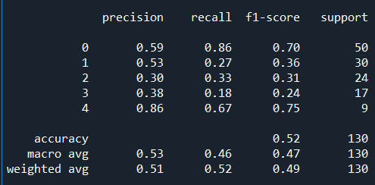

Train-Val Graphs:

